CONTINUOUS DEPLOYMENT WITH KUBERNETES
CI/CD Integration and Automated Manifest Application

1. Objective
The objective is to configure a continuous deployment workflow in which a source-code change triggers a CI/CD pipeline. The pipeline builds a container image, pushes it to a container registry, updates/applies the Kubernetes manifests, and waits for the Kubernetes Deployment rollout to complete.

2. Tools and Technologies
- Git and GitHub
- GitHub Actions (CI/CD)
- Docker
- Container Registry such as GitHub Container Registry (GHCR)
- Kubernetes
- kubectl

3. Kubernetes Deployment Manifest
Create k8s/deployment.yaml. The image tag is replaced during the deployment workflow so that each pipeline run can deploy a specific build.
apiVersion: apps/v1
kind: Deployment
metadata:
name: demo-web
spec:
replicas: 3
strategy:
type: RollingUpdate
selector:
matchLabels:
app: demo-web
template:
metadata:
labels:
app: demo-web
spec:
containers:
- name: demo-web
image: ghcr.io/OWNER/demo-web:IMAGE_TAG
ports:
- containerPort: 80
---
apiVersion: v1
kind: Service
metadata:
name: demo-web
spec:
selector:
app: demo-web
ports:
- port: 80
targetPort: 80

4. CI/CD Workflow
Create .github/workflows/deploy.yml. The workflow below runs whenever changes are pushed to the main branch.
name: Build and Deploy to Kubernetes
on:
push:
branches: [ "main" ]
permissions:
contents: read
packages: write
jobs:
deploy:
runs-on: ubuntu-latest
steps:
- name: Checkout
uses: actions/checkout@v4
- name: Log in to GHCR
uses: docker/login-action@v3
with:
registry: ghcr.io
username: ${{ github.actor }}
password: ${{ secrets.GITHUB_TOKEN }}
- name: Build and Push Image
run: |
docker build -t ghcr.io/${{ github.repository_owner }}/demo-web:${{ github.sha }} .
docker push ghcr.io/${{ github.repository_owner }}/demo-web:${{ github.sha }}
- name: Configure kubectl
uses: azure/setup-kubectl@v4
- name: Configure cluster access
run: |
echo "${{ secrets.KUBE_CONFIG }}" > kubeconfig
export KUBECONFIG=$PWD/kubeconfig
kubectl cluster-info
- name: Deploy
run: |
export KUBECONFIG=$PWD/kubeconfig
sed -i "s|IMAGE_TAG|${{ github.sha }}|g" k8s/deployment.yaml
sed -i "s|OWNER|${{ github.repository_owner }}|g" k8s/deployment.yaml
kubectl apply -f k8s/deployment.yaml
kubectl rollout status deployment/demo-web --timeout=180s

5. Configure CI/CD Secrets
Store cluster credentials in GitHub repository settings under Secrets and variables → Actions. A typical setup uses KUBE_CONFIG containing the kubeconfig required to authenticate to the Kubernetes cluster.
- KUBE_CONFIG — Kubernetes kubeconfig content
- GITHUB_TOKEN — automatically provided by GitHub Actions for GHCR package publishing (when permissions are configured)

6. Trigger the Pipeline
Commit and push the application changes to the main branch:
git add .
git commit -m "Deploy application to Kubernetes"
git push origin main
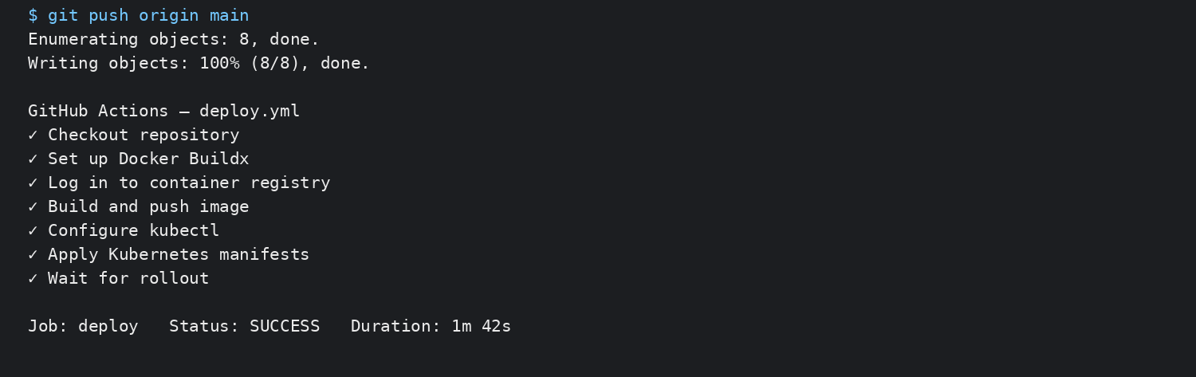
Figure 1. CI/CD workflow completing the automated build and deployment (representative expected output).

7. Build and Push Container Image
The pipeline builds the Docker image and tags it with the Git commit SHA. Using an immutable commit-based tag makes it possible to identify exactly which source revision was deployed.
docker build -t ghcr.io/OWNER/demo-web:$GITHUB_SHA .
docker push ghcr.io/OWNER/demo-web:$GITHUB_SHA

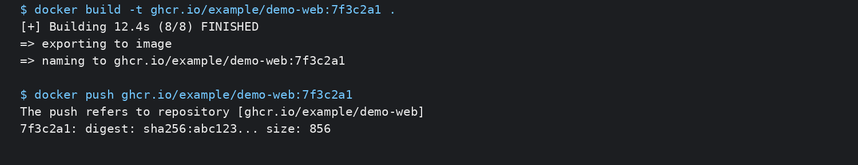
Figure 2. Container image build and registry push (representative expected output).

8. Automated Kubernetes Manifest Application
After the image is pushed, the workflow substitutes the image tag and runs kubectl apply. The rollout-status command makes the job fail if the Deployment does not complete successfully within the configured timeout.
kubectl apply -f k8s/deployment.yaml
kubectl rollout status deployment/demo-web --timeout=180s

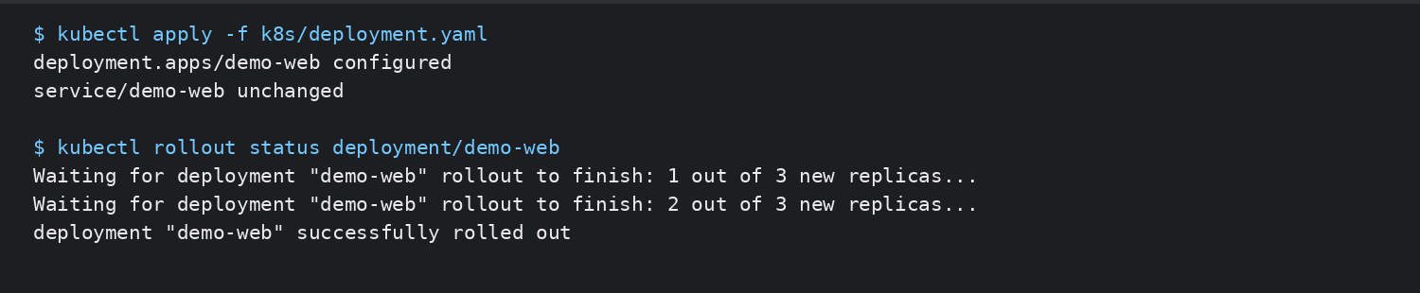
Figure 3. Automated manifest application and successful rollout (representative expected output).

9. Verify the Deployment
kubectl get deployment demo-web
kubectl get pods
kubectl get deployment demo-web -o jsonpath='{.spec.template.spec.containers[0].image}'

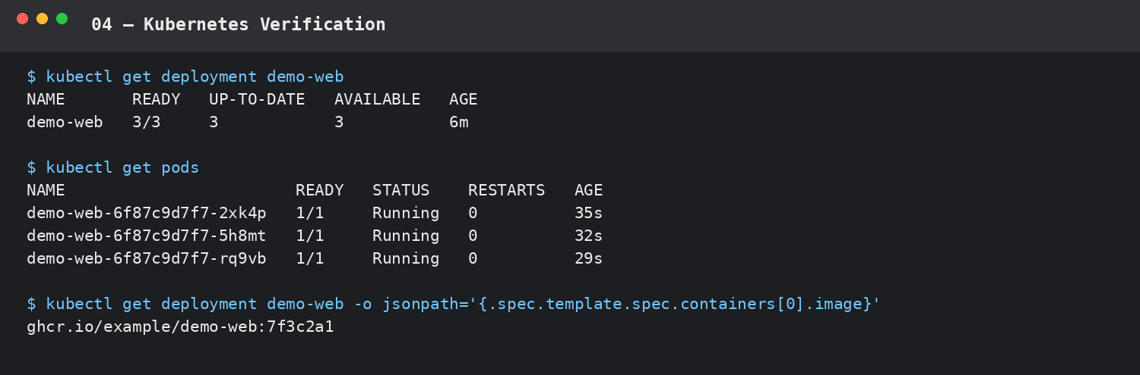
Figure 4. Kubernetes Deployment, Pods, and deployed image verification (representative expected output).

10. Demonstrate Continuous Deployment
A second commit to the main branch repeats the same workflow automatically. The new commit receives a new image tag, the manifest is updated, and Kubernetes performs a rolling deployment.
git commit -m "Update application version"
git push origin main
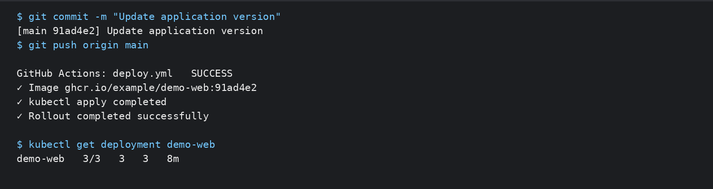
Figure 5. A subsequent commit automatically triggers another deployment (representative expected output).

11. Deployment Flow
The resulting continuous-deployment flow is:
- Developer pushes code to main
- GitHub Actions starts automatically
- Source code is checked out
- Docker image is built
- Image is pushed to the container registry
- Kubernetes credentials are loaded
- Manifest image tag is updated
- kubectl apply applies the manifest
- Kubernetes performs the rolling update
- rollout status verifies successful deployment

12. Result
Continuous deployment was configured by integrating GitHub Actions with Kubernetes. A push to the main branch triggers the pipeline, which builds and publishes a container image, applies the Kubernetes manifest automatically, and verifies the rollout. A second commit demonstrates that the process can repeat without manually executing kubectl commands from the developer's machine.

13. Conclusion
CI/CD automation reduces manual deployment steps and provides a repeatable path from source-code change to a running Kubernetes workload. Combining immutable image tags, automated manifest application, and rollout verification also makes deployments easier to trace and validate.

